Abundance and Diversity of Soil Mites (Acariformes and Parasitiformes) in Two Tropical Forests from Panama

Lariza Mendoza³, Ramy Jhasser Martínez^{1,2*,} Dora Isabel Quirós², Ariel Magallón^{3,4} and Gabriel Villegas-Guzmán^{5*}

1 Center for Genomics, Ecology & Environment (GEMA), Universidad Mayor, Camino La Piramide, 5750, Santiago 8580745, Chile
2 Departamento de Zoología. Facultad de Ciencias Naturales y Tecnologías. Universidad de Panamá.
3 Departamento de Genética y Biología Molecular. Facultad de Ciencias Naturales y Tecnologías. Universidad de Panamá.
4 Instituto Conmemorativo Gorgas de Estudios de la Salud. Panamá.
5 Laboratorio de Acarología, Departamento de Zoología Escuela Nacional de Ciencias Biológicas, Instituto Politécnico Nacional, Prolongación de Carpio y Plan de Ayala, S/N. Col. Santo Tomás, CP 11340 Ciudad de México, México.
*Correspondence: ramy.martinez@mayor.cl, ramy.martinez@up.ac.pa; gabrvill@gmail.com

Abstract
Tropical forest soils harbor a considerable diversity of organisms, with mites standing out as representative components of the mesofauna. Despite their abundance and diversity, the ecology and taxonomy of these microarthropods still need to be studied. This work describes and compares the abundance and diversity of mites in the soils of two forested areas in the Province of Panama: PNM (Parque Natural Metropolitano) and PNS (Parque Nacional Soberania). Monthly collections were conducted over six months, establishing transects with three sampling points in both sites. Pitfall traps and Berlese-Tullgren funnels were used to collect mites. A total of 421 mites belonging to 53 genera and 33 families were identified. In PNM, the most abundant families were Nehypochthoniidae, Galumnidae, Scheloribatidae, and Macrochelidae, while in PNS, Macrochelidae, Parasitidae, and Nehypochthoniidae stood out. The highest diversity in PNM was observed within Lohmanniidae, Haplozetidae, Macrochelidae, Scheloribatidae, and Oppiidae, whereas in PNS, Macrochelidae prevailed. PNM exhibited greater abundance, diversity, and richness of soil mites, with Mesostigmata and Sarcoptiformes being the most representative orders, and Oribatids as the most abundant group.
Keywords
Microarthropods; mesofauna; pitfall traps
Introduction
The mites are one of the oldest, most abundant, and diverse groups of arthropods (Krantz & Walter, 2009; Coleman et al., 2004) They inhabit different types of habitats in the soil, forests, desert regions, polar areas, and marine and freshwater environments. Some species are parasites of birds, mammals, reptiles, and amphibians (Pérez et al., 2014; Dhooria, 2016; Domínguez et al., 2020). Soil mites are small organisms, ranging in size from 0.1 mm to 3 cm in length, representing up to 85% of the soil invertebrate fauna (Krantz & Walter, 2009; Morais et al., 2013).
Currently, there are approximately 64,000 described species of mites worldwide, grouped into two superorders: Acariformes and Parasiti-formes (Krantz & Walter, 2009). The Acariformes superorder is the most diverse, comprising the Trombidiformes order and the Sarcoptiformes order, the latter including the Endeostigmata and Oribatida suborders. The Parasitiformes superorder contains four orders: Opilioacarida, Hol-othyrida, Mesostigmata, and Ixodida (Krantz & Walter, 2009).
Many members of Acariformes and Parasitiformes are free-living, preying upon dif- ferent animal groups or feeding on fungi, bacteria, pollen or on decaying organic material or sugary substrates; others are phytophagous or parasitic on invertebrates or vertebrates (Dhooria, 2016). The Oribatida are one of the most representative groups of soil mites (Krantz & Walter, 2009). Some subterranean species feed on roots, while others take advantage of plant disturbances caused by fungi (Krantz & Lindquist, 1979) to disperse mycorrhizal propagules after feeding. They also can attack plant-parasitic fungi in the rhizosphere, benefiting the plant (Rabatin & Rhodes, 1982; Schneider et al., 2005).
The order Mesostigmata order comprises one of the dominant mite groups in the soil, including ecologically important families that are predators of small invertebrates, as insects' mites and nematodes (Dhooria, 2016). Therefore, they can be used to control pests causing significant plant diseases (Beretta et al., 2022). Additionally, they can be employed for mushroom cultivation as spore dispersers, for fly larvae control (Sciaridae) (Dhooria, 2016; Castilho et al., 2009; Jess & Schweizer, 2009), and as bioindicators of soil quality in natural or disturbed envi-ronments (Dhooria, 2016; Lima et al., 2018).
Mites and springtails are the most representative groups of soil microarthropods, contributing to organic matter decomposition and soil structure formation and maintenance. Hence, they are considered bio-indicators of soil ecological status (Socarrás et al., 2019).
There is a diversity of soil microhabitats that mites typically exploit for residence. They are commonly found in decomposing organic matter deposits and in soil interstices or pores, where the highest diversity and abundance of species occur (Hansen, 2000; Palacios-Vargas et al., 2009). The decomposition of different types of litter and its relationship with subterranean and surface processes contribute minerals (Wardle, 2006), allowing tree roots to penetrate deeper into the soil, enabling mites to reach greater depths (Gabet et al., 2003).
In rainforests and dry tropical forests, the ability to maintain litter accumulation for a transiently longer period allows mites and arthropods, in general, to be more abundant at the beginning of the rainy season due to litter degradation (Levings & Windsor, 1982). The high diversity of soil mites, in general, is one of the great mysteries of tropical soil ecology. While the biodiversity of soil microarthropods is well-characterized in deciduous forests, taxonomic knowledge of this soil component in tropical forests is poor. Despite the extensive literature on the Oribatida suborder, accurately identifying genera, families, and even superfamilies in the Neotropics poses significant challenges. Therefore, a continuous effort of research and sampling in relevant regions is needed to address these limitations and enhance our understanding of soil mite diversity in the tropics (Noti, 2003; Franklin, 1992; Franklin, 2004). Considering pre-vious research on soil arthropods in general in the country (Sayer, 2010; Basset, 2012; Basset, 2015), which focuses on ecological aspects without specific group targets, there is a lack of information about soil-associated organisms in Panama. To date, the most relevant studies on soil mites in the country have been primarily taxonomic in nature, such as those conducted by Subías et al. (Subías, 2004), on Coiba Island and Kontschán (Kontschan, 2010).
The objective of this study was to assess and compare the population density and species richness of soil mites in two tropical humid forests within Panama: The Metropolitan Natural Park (PNM) and the Soberanía National Park (PNS). We focused on two suborders of mites: Oribatida, and Mesostigmata. Our hypothesis posits that Soberanía National Park harbors a greater diversity and abundance of soil mites compared to Metropolitan Natural Park. This prediction stems from the assumption that the heightened anthropogenic activity in Metropolitan Natural Park leads to a reduction in both the diversity and abundance of soil mites, attributable to the impact of human use.
Materials and Methods
Description of Study Areas
The study was conducted in two protected areas within the Province of Panama: The Parque Natural Metropolitano (PNM) and the Parque Nacional Soberania (PNS). PNM is located on the Pacific side of Panama City, covering about 232 hectares (PNM, 2023). It consists of a tropical rainforest (PNM, 2023; Holdridge, 1967) with an average annual rainfall of 1850 mm and an average annual temperature of 30°C. It contains 633 registered plant species, including common vegetation like bryophytes, lianas, higuerón, bromeliads, and large trees such as barrigón (Pseudobombax septenatum), rubber (Hevea brasiliensis), cuipo (Cavanillesia platanifolia), cedar (Cedrela odorata), espavé (Anacardium excelsum), guayacán (Handroanthus guayacan), and more (PNM, 2023).
PNS is situated along the Panama Canal (ANAM, 1999), covering about 22,104 hectares (Holdridge, 1967). It represents a tropical rainforest with an average annual rainfall of about 2000 mm and an average annual temperature of 26ºC (ANAM, 1999; Mi, 2018). The park is home to 2762 registered plant species, including ferns, heliconias, bijaos (Cannaceae), anthuriums, and other plants. It features large trees such as cedar (Cedrela odorata), Miconia argentea, Scheelea zonensis, Sande (Brosimum sp.), Pyalenthera sp., espavé (Anacardium excelsum), amargoso (Astronium graveolens), roble (Tabebuia rosea), guayacán (Tabebuia guayaca), and many more (Mi, 2017).
Sampling
The experimental design involved systematically collecting mites over a period of six consecutive months, from March to August 2021, in two tropical humid forests in Panama: PNM and the PNS. Three transects were established in each study area, each with a length of 45 meters, strategically located 50 meters away from the main trail of the park, which is frequently traversed by people. Within each transect, sampling points were selected at 15-meter intervals, resulting in three sampling points per transect and a total of nine sampling points across both study sites over the six-month period. At each sampling point, a 3-in-1 soil meter was used to assess soil pH, light, and moisture levels. Additionally, Pitfall traps containing a 70% ethanol solution were deployed for 72 hours to capture soil mites. Soil samples of 350 cc (10x10 cm) were collected at each sampling point and stored in labeled airtight plastic bags, including trap number, sampling date, and study site information. A total of 54 soil samples and 54 Pitfall traps from each site were reviewed, totaling 216 samples from both sites.
Sample Processing
The samples were transported to the Laboratory of Ecology and Neotropical Biodiversity of the Vice Presidency of Research and Post-graduate Studies at the University of Panama for processing. The total soil volume was placed in Berlese-Tullgren funnels and left under incan-descent light from 60 W bulbs for seven days to allow microarthropods to migrate to the bottom of the funnel and be captured in a reservoir con-taining 70% ethanol for preservation (Palacios-Vargas et al., 2007). The material obtained from Pitfall traps and soil samples processed by Ber-lese-Tullgren funnels was examined using a Carl Zeiss, Stemi 305 ste-reoscope. The mites were manipulated with fine brushes, separated into morphotypes of Acariformes and Parasitiformes mites, and preserved in 70% ethanol. The mites were cleared with lactophenol and mounted using Hoyer’s medium using the methodology of Krantz & Walter (Krantz & Walter, 2009). The specimens were deposited in the Laboratory of Ecology and Neotropical Biodiversity Collection of the University of Panama.
Taxonomic Identification
Using a Nikon YS 100 compound microscope and based on taxo-nomic keys by Krantz & Walter (Krantz & Walter, 2009), the identifica-tion of individuals was carried out by evaluating their morphological characters. Individuals were recorded up to the family and genus level Balogh & Balogh (Balogh & Balogh, 1988; Balogh & Balogh, 1990; Balogh & Balogh, 1992), (Trach & Seeman, 2014; Kazemi et al., 2014; Krantz, 2018; Krantz, 1904; Hyatt, 1988; Kazemi et al., 2013; Mahboubeh et al., 2018; Castilho et al., 2016; Kontschán, 2007; Kontschán, 2015; Veigaia, 2023), and those unable to be recognized at the genus level were clas-sified as genus.
Data Analysis
The complete dataset consisted of 216 samples collected by two collection methods. Mite abundance was assessed using tables and de-scriptive graphs. Taxonomic diversity of mites between both parks at the genus level was estimated through an individual rarefaction analysis by comparing richness index (S), Shannon index (H), Simpson index (1/D), and alpha diversity profile. Shannon and Simpson diversity indices were compared using a t-diversity test at a significance level of p < 0.05. A principal component analysis was conducted to determine the genera that marked the overall difference between both parks. All analyses were performed using Past 4.11 software (Hammer et al., 2001).
Results
A total of 608 individuals were collected, with 337 in PNM and 271 in PNS. Among the mites collected in PNM, 67 could not be identified at any taxonomic level due to immaturity or damage; 6 were identified only to order, 104 only to family, and 162 (48.4%) to genus. Similarly, in PNS, 41 mites could not be identified, 4 were classified only to order, 111 to family, and 113 (41.6%) to genus. The final analysis included all 275 individuals identified to the genus level from soil core collections at both sites.
Diversity was rich within PNM, where 31 families of soil mites were documented, with Nehypochthoniidae (13%), Galumnidae (11%), Scheloribatidae (10%), and Macrochelidae (10%) being the most abundant (Figure 1), yet only 24 of these families were classified to the genus level. PNS reported 23 families with a predominance of Macrochelidae (20%), Parasitidae (14%), and Nehypochthoniidae (9%) (Figure 2). Out of these, 16 families were specified to the genus level, with Macrochelidae again showing the most diversity (Table 2). The Lohmanniidae family was noted for the greatest genus diversity in PNM, followed by Haplozetidae, Macrochelidae, Scheloribatidae, and Oppiidae (Table 1). The genera Macrocheles (Macrochelidae) and Gamasiphis (Ologamasidae), both from the Mesostigmata order, topped the abundance charts (Table 1). In both parks, the genera Parasitellus (Parasitidae) and Macrocheles were highly populous, with notable numbers also found in Gamasiphis (Ologamasidae), Dermacentor (Ixodidae), and Parasitellus (Table 1, Table 2).
This study constitutes the first documentation of the Nehypochthoniidae family and adds 18 new genera records in the country (Table 1, Table 2). Principal component analysis (PCA) highlighted the pre-dominance of Macrocheles and Parasitellus in PNS, and Gamasiphis in PNM, highlighting not only their abundance but also the richness of species in these locations (Figure 3). When comparing gender diversity, PNM excelled over PNS, as indicated by the richness indices and the values obtained from Shannon (3.58) and Simpson (0.95) indices, along with a diversity test comparison of the groups (p < 0.0001) (Figure 4). Despite the use of pitfall traps and soil samples yielding 259 and 172 mites respec-tively, soil parameters such as pH, light, and humidity were not sig-nificantly different between the two sites (P > 0.05), indicating that these environmental variables did not have a discernible effect on the dis-tribution of soil mites between PNM and PNS.

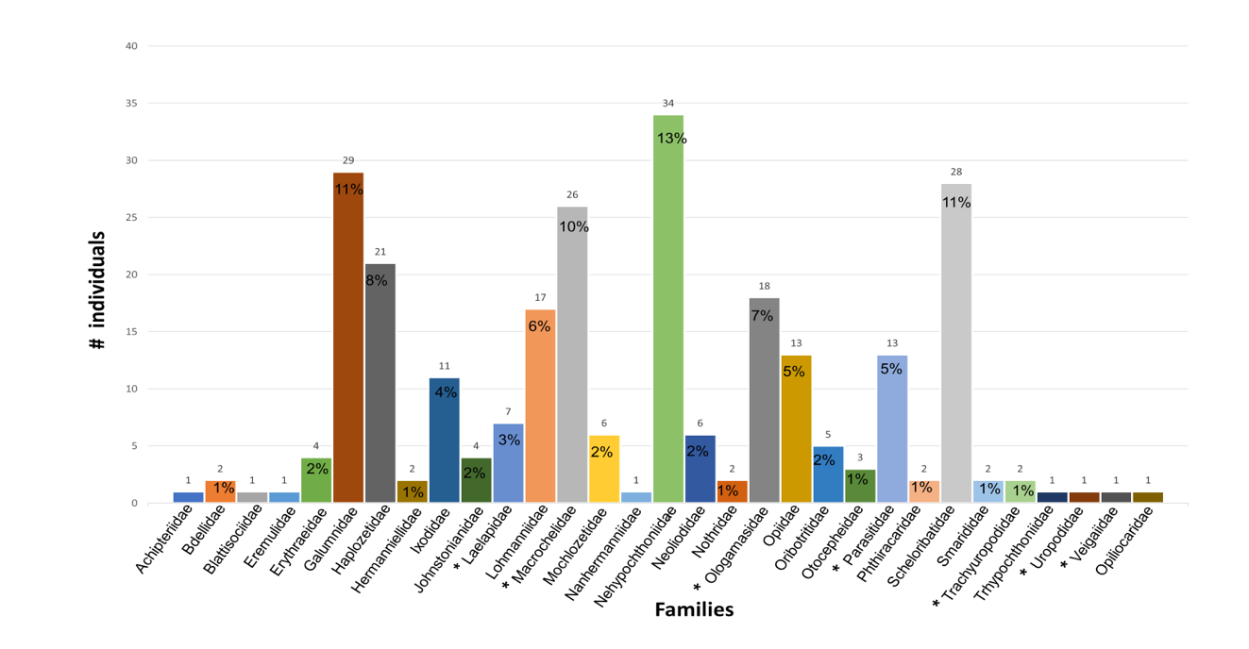

Figure 1. Distribution of individual abundance among families within the PNM. (*) Mesostigmata.

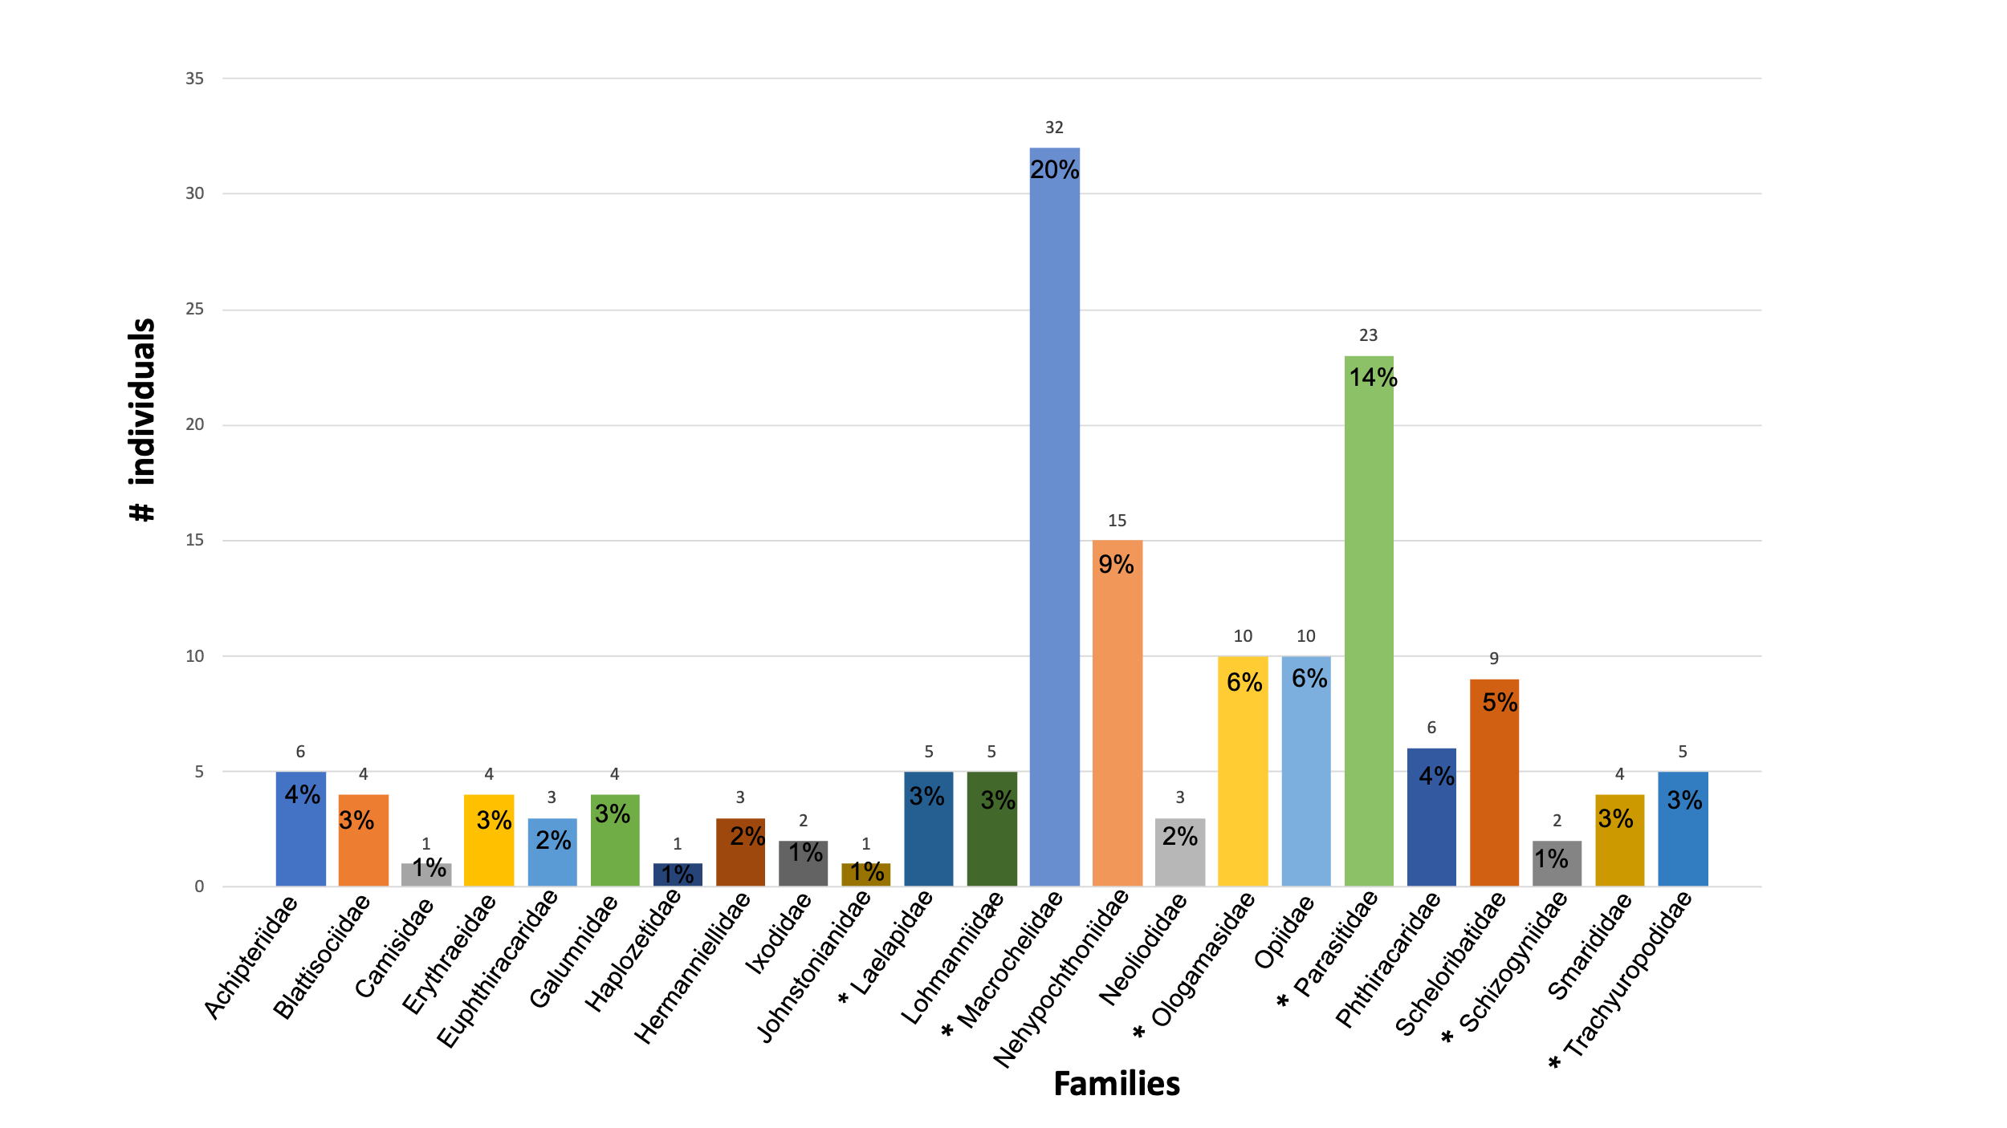
Figure 2. Distribution of individual abundance among families within the PNS. (*) Mesostigmata.

Figure 3. Principal Component Analysis. Dominant soil mite genera in terms of abundance within PNM and PNS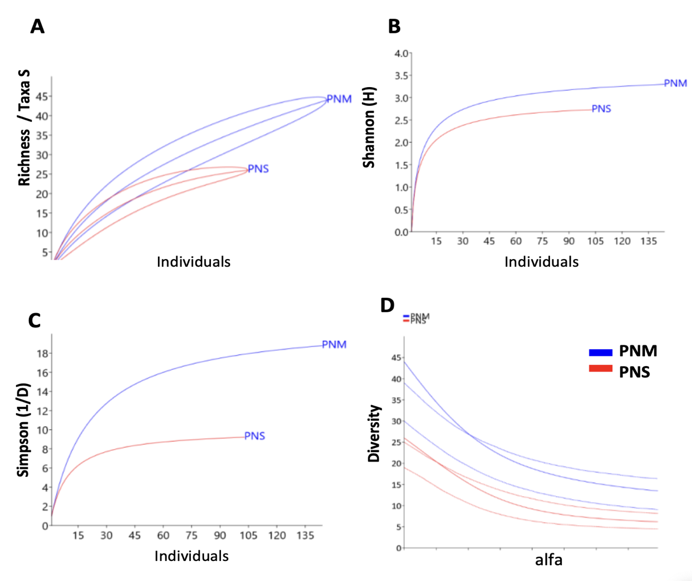
Figure 4. Richness and diversity of mites in PNM and PNS. Graphical comparison of richness (A), diversity (B), and (C) dominance of mite genera in PNM and PNS. Comparison of diversity indicators of mite genera by study site (D).
Discussion
The study unveiled a remarkable diversity of soil mites with the inclusion of new records for the country, broadening our understanding of biodiversity in the surveyed ecosystems. Discoveries of genera such as Dicondyla within the Otocepheidae and multiple members of the Lohmanniidae family, including Austracarus, Lohmannia, Papillacarus, and Thamnacarus, indicate a more complex and varied mite community than previously recognized. The identification of Nanhermannia from the Nanhermanniidae family, and Neoliodes from the Neoliodidae, along with representatives from the Opiidae, Haplozetidae, Mochlozetidae, and Phthiracaridae, suggests that the taxonomic diversity in these hab-itats may be influenced by microecological factors not yet fully under-stood. The significant presence of families like Nehypochthoniidae, recorded for the first time in the area, underscores the need for continued research in these biomes. Such discoveries not only enrich taxonomic catalogs but may also signal ecological aspects of the soils in PNM and PNS that favor the presence of these taxa. Species from the Scheloribatidae and Haplozetidae families, such as Similobates, Conozetes, Paraleius, and Trachyoribates, reinforce the notion that generic diversity is a valuable indicator of the health and complexity of the soil ecosystem.
The abundance of Oribatids such as Nehypochthoniidae, Ga-lumnidae, and Scheloribatidae found in the PNM may be associated with soils with low anthropogenic impact, aligning with reports by Accattoli & Salazar Martínez (Accattoli & Salazar Martínez, 2012). (Within this last family, the genus Scheloribates stands out. The families Nehypochtho-niidae, Galumnidae, Scheloribatidae, and Macrochelidae that predom-inated in the PNM also tend to be more abundant in humid tropical forests (Accattoli & Salazar Martínez, 2012; Hubert, 2000; Villagómez et al., 2019). The Nehypochthoniidae family is a group of mites with little available information, but it is known that they feed on fungal hyphae (Swift & Norton, 1998). Norton & Merz (Norton & Metz, 1980) mention that they are parthenogenetic, as there is a notable absence of males in large populations. Due to the lack of keys and information in general, it was not possible to identify genera; however, only one morphospecies was found for this family.
The Galumnidae family, one of the most observed groups of the order Oribatida (Rabatin & Rhodes, 1982), has a broad trophic spectrum, feeding on organic debris, fungal hyphae, spores, nematodes, and showing a preference for plant tissues (Woodring, 1965; Oliveira et al., 2007). The mites of the Scheloribatidae family have a cosmopolitan dis-tribution (Subías, 2002), and some are phoretic on bark beetles (Scolyt-inae) of the family Curculionidae, observed in the galleries of their hosts (Ahadiyat & Akrami, 2015). The presence of these mites may be related to ecological interactions with bark beetles associated with trees such as Cedrela odorata (Pulgarín, 2012).
Free-living predatory mites belong to the order Mesostigmata, making them prevalent among soil mites (Castilho et al., 2009). There-fore, the most abundant families found in the PNS are Parasitidae and Macrochelidae, indicating an ecosystem dominated by predators. The genus Parasitellus, belonging to the family Parasitidae, engages in phoresy in the deutonymph stage with some bumblebee species, and in other stages of its life cycle, it is free-living, feeding on pollen and mi-croarthropods (Revainera, 2019; Karg, 1993; Richards, 2018). Within the Macrochelidae family, Macrocheles is the most diverse genus (Krantz, 1930), while Gamasiphis is one of the most diverse genera in the family Ologamasidae and is one of the most aggressive predators among soil mites (Castilho et al., 2010). These predators play a crucial role in the decomposition of organic matter, nutrient recycling, and maintaining the balance of the soil ecosystem by feeding on nematodes, insects, and other free-living mites (Vu & Nguyen, 2000). They also tend to be intraguild predators (Parimuchová et al., 2021). Rueda et al. (Rueda-Ramírez et al., 2019) observed predation even within the same species of mites, from adult stages to immatures.
The families Lohmanniidae and Haplozetidae showed the greatest diversity in this study, consistent with reports by Hammer & Wallwork (Hammer & Wallwork, 1979), highlighting that the Lohmanniidae family has a wider distribution in tropical and subtropical regions. These families feed on decomposing leaves and endophagically in woody substrates (Haq, 1982; Ramani & Haq, 1991). Some of their species, like those of the Haplozetidae family, are parthenogenetic (Norton & Palmer, 1991; Maraun et al., 2004). The families Lohmanniidae, Haplozetidae, and Scheloribatidae are among the families with the highest species richness and are among the most diverse in tropical forests (Grandjean, 1958; Schatz & Schuster, 2012; Oliveira et al., 2017).
In tropical forests, the Oribatida group of free-living mites, which have an affinity for leaf litter, demonstrate significant abundance and diversity. This is particularly evident as leaf litter degrades with the onset of the rainy season, promoting a rich and diverse mesofauna community (Krantz & Walter, 2009; Martínez-Falcón et al., 2015). Humidity is known to expedite the decomposition of organic matter (Beaulieu et al., 2010), and the resultant diversity, thickness, and volume of leaf litter enrich the soil with a spectrum of nutrients, thereby enhancing the diversity and abundance of mites (Castilho et al., 2015; Gill, 1969). A homogenous layer of leaf litter can, however, constrain root penetration and, by extension, the diversity of soil mite species (Hansen, 2000; Hansen & Coleman, 1998). The intricate symbiosis of soil dwellers, including mites, insects, and other mesofauna, is pivotal for the health and equilibrium of soil ecosystems. The Oribatida are particularly prevalent in forested regions, playing an essential role in organic matter breakdown and soil genesis. In contrast, their numbers are noticeably reduced in agricultural settings, due to a predilection for organically rich soil layers—more typical of forests than agricultural fields, which often suffer disturbance and may lack the requisite organic materials these mites necessitate (Norton, 1990). This proclivity underscores the necessity of preserving organic matter within soil ecosystems to foster varied mite communities, which are in-dispensable for nutrient cycling and overall ecosystem functionality. The Oribatida specialized anatomical features, like robust exoskeletons, act as effective defenses against predators, allowing them to prosper in the competitive soil milieu. Their triumph in forest environments may also signify their vital contribution to soil structure and nutrient dynamics, augmenting the fertility and productivity of the forest substrate. Con-versely, the Mesostigmata order, esteemed for predatory tendencies, emerged as the most copious genera observed. Their salient role as apex predators is vital in preserving ecological harmony, regulating the populations of other organisms, and hindering any one group from becoming overly dominant. Their presence is indicative of a vigorous ecological structure, emblematic of an efficiently operating ecosystem with sustained energy flow and nutrient recycling (Chaires-Grijalva et al., 2016; Koehler, 1998).
Behan-Pellentier (Behan-Pelletier, 1999) has identified the family Oppidae as an indicator of recent disturbances in both forest and agroecosystem environments. The strong association of families such as Eupthiracaridae, Pthiracaridae, Carabodidae, Dampfielidae, Otoce-pheidae, Nanhermanniidae, Northridae, Oppidae, Gymnodamaeidae, Liacaridae, and Scheloribatidae (Oribatida) with forest habitats suggests that these families can serve as indicators of stable habitats with minimal disturbance and abundant resources (food and shelter within the leaf litter layers). Oribatid mites, especially those with long development times, low fecundity, and high adult longevity, are often found in forest habitats. This is in line with other research, including that by Maribie et al. (Maribie et al., 2011), which interprets that natural tropical forests harbor a greater diversity of mites than disturbed zones and agroeco-systems. Our study did not find significant differences in soil parameters such as pH, light, and humidity between the two national parks, suggesting stability in soil mite distribution despite seasonal variations. This finding contrasts with Maribie et al. (Maribie et al., 2011), who did not mention seasonal differences, although other studies have reported that mite abundance and diversity vary with the seasons, with humid seasons exhibiting greater abundance and diversity compared to dry periods (Badejo & Akinwole, 2006; Badejo et al., 2002; Badejo & Tian, 1999; Badejo, 1990; Purvis & Curry, 1980; Chaires-Grijalva et al., 2013; Minor & Cianciolo, 2007; Luxton, 1981). Genera such as Macrocheles and Gamasiphis, notable for their abundance, may also serve as indicators of specific environmental conditions in Neotropical regions.
PNM and the nearby park PNS are classified as tropical rainforests (Holdridge, 1967). Based on environmental parameter analyses, both sites exhibit similar environmental traits. Sampling points in PNM and PNS, located away from human-trafficked trails, indicate that the mite populations in these parks can be seen as bioindicators of soil health.
The collection methods, Pitfall traps, and soil sampling used for capturing soil mites in this study allowed for the capture of different mite genera. These collection methods are economical and practical (Chaires-Grijalva et al., 2013); however, they have certain disadvantages that can influence the quantity and quality of the collected organisms. During sampling, some Pitfall traps filled with water on rainy days, diluting the alcohol content inside the trap and affecting the collected individuals as they decomposed, and many were lost, reducing the actual abundance of the collection. Nevertheless, it can be said that both col-lection methods are viable and complement each other, so it is recom-mended to use them together.
The findings of this study in the two tropical forests of Panama, particularly highlighting PNM, present a compelling narrative about the ecological dynamics governing soil mite populations. The PNM stands out with its richer soil mite communities, demonstrating not only a higher count of individuals but also a more diverse and extensive range of species. This suggests a thriving microecosystem, potentially fostered by the park's unique vegetation and microhabitat structures that support a complex web of life. The differences in the diversity of mite families observed between the two study sites underscore the significant impact of local vegetation and its interplay with various soil organisms. The diverse flora offers a variety of niches, each supporting different mite families and fostering a web of ecological relationships.
The nuanced understanding of these soil communities gleaned from our study is critical. It not only expands our taxonomic knowledge and biodiversity records but also provides insights into the functioning of tropical forest ecosystems. It emphasizes the importance of conserving such environments, as they are hotspots of biodiversity and pivotal in maintaining the ecological processes that are vital for the forest's resili-ence and the larger global ecosystem. This study contributes to studies of soil mites in neotropical regions and in turn lays the foundation for future ecological research and conservation efforts on mites in Panama.
Author Contributions: Conceptualization, R.J.M., D.I.Q. and A.M; Formal analysis, L.M, R.J.M., D.I.Q., G.V.G. and A.M; Methodology, L.M, R.J.M., D.I.Q., G.V.G. and A.M; Resources, L.M, R.J.M., D.I.Q., G.V.G. and A.M; Supervision, R.J.M., D.I.Q. and G.V.G; Visualization, R.J.M., D.I.Q. and A.M; Writ-ing—original draft, L.M, R.J.M., D.I.Q., G.V.G. and A.M; Writing—review & editing, L.M, R.J.M., D.I.Q., G.V.G. and A.M. All authors have read and agreed to the published version of the manuscript.
Funding: This research was funded by Vicerrectoría de Investigación y Post-grado, Universidad de Panamá, Project: CUFI -2019-CNET-EG-009; CU-FI-2022-CNET-EP-008; and SENACYT, Project: APY-NI-2019-30
Acknowledgments: The authors express their gratitude to the Vicerrectoría de Investigación y Postgrado of the Universidad de Panamá, SENACYT, Instituto Conmemorativo Gorgas for providing the funding support for this research.
Conflicts of Interest: The authors declare no conflict of interest.
References

1. Krantz, G. W., & Walter, D. E. (2009). A Manual of Acarology, 3rd ed.; Texas Tech University Press: Lub-bock, TX, USA, ; pp. 509, ISBN 978-0896726208.
2. Coleman, D. C., Crossley Jr, D. A., & Hendrix, P. F. P. (2004). Fundamentals of Soil Ecology, 2nd ed.; Else-vier Academic Press: San Diego, USA, ; pp. 408, ISBN 0-12-179726-0.
3. Pérez, T. M., Guzmán-Cornejo, C., Montiel-Parra, G., Paredes-León, R., & Rivas, G. (2014). Biodiversity of Acari in Mexico. Rev Mex Biodivers, 85, S399–S407, https://doi.org/10.7550/rmb.36160.
4. Dhooria, M. S. (2016). Fundamentals of Applied Acarology, 1st ed.; Springer: Singapore, SGP, ; pp. 470, ISBN 978-981-10-1594-6.
5. Domínguez, L., Cleghorn, J., & Bermúdez, S. E. (2020). Una revisión de los ectoparásitos de serpientes en Panamá. Scientia, 30, 1–6, https://doi.org/10.48204/j.scientia.v30n1a1.
6. Morais, J. W. De., Oliveira, F. G. L., Braga, R. F., & Korasaki, V. (2013). Mesofauna. In O ecossistema solo: componentes, relações ecológicas e efeitos na produção vegetal, 1st ed.; Moreira, F.M.S., Cares, J.E., Zanetti, R., Stürmer, S.L., Eds.; Editora da UFLA: Lavras, BR, ; pp. 185–200, ISBN 9788581270234.
7. Krantz, G. W., & Lindquist, E. E. (1979). Evolution of phytophagous mites (ACARI). Annu Rev Entomol, 24, 121–158, https://doi.org/10.1146/annurev.en.24.010179.001005.
8. Rabatin, S. C., & Rhodes, L. H. (1982). Acaulospora Bireticulata inside Oribatid mites. Mycologia, 74, 859–861, https://doi.org/10.2307/3792878.
9. Schneider, K., Renker, C., & Maraun, M. (2005). Oribatid mite (Acari, Oribatida) feeding on ectomycorrhi-zal fungi. Mycorrhiza, 16, 67–72, https://doi.org/10.1007/s00572-005-0015-8.
10. Beretta, G. M., Deere, J. A., Messelink, G. J., Muñozk-Cárdenas, K., & Janssen, A. (2022). Review: Predatory soil mites as biocontrol agents of above- and below-ground plant pests. Exp Appl Acarol, 87, 143–162, https://doi.org/10.1007/s10493-022-00723-w.
11. Castilho, R. C., de Moraes, G. J., Silva, E. S., Freire, R. A. P., & Eira, F. C. (2009). The predatory mite Stra-tiolaelaps scimitus as a control agent of the fungus gnat Bradysia matogrossensis in commercial produc-tion of the mushroom Agaricus bisporus. Int J Pest Manag, 55, 181–185, https://doi.org/10.1080/09670870902725783.
12. Jess, S., & Schweizer, H. (2009). Biological control of Lycoriella ingenua (Diptera: Sciaridae) in commercial mushroom (Agaricus bisporus) cultivation: A comparison between Hypoaspis miles and Steinernema fel-tiae. Pest Manag Sci, 65, 1195–1200, https://doi.org/10.1002/ps.1809.
13. Lima, D. B., Rezende-Puker, D., Mendonça, R. S., Tixier, M. S., Gondim, M. G. C., Melo, J. W. S., Oliveira, D. C., & Navia, D. (2018). Molecular and morphological characterization of the predatory mite Amblyseius largoensis (Acari: Phytoseiidae): surprising similarity between an Asian and American populations. Exp Appl Acarol, 76, 287–310, https://doi.org/10.1007/s10493-018-0308-1.
14. Socarrás, A. A., Dávila, G. C., Robaina, N., & de León, D. P. (2019). Taxonomic composition of the edaphic mesofauna in soils of ferralitic composition from Artemisa and Mayabeque, Cuba. Acta Bot Cub, 218, 109–119, https://revistasgeotech.com/index.php/abc/article/view/291.
15. Hansen, R. A. (2000). Effects of habitat complexity and composition on a diverse litter microarthropod assemblage. Ecology, 81, 1120–1132, https://doi.org/10.1890/0012-9658(2000)081[1120: EO-HCAC]2.0.CO;2.
16. Palacios-Vargas, J. G., Mejía-Recamier, B. E., & Cutz-Pool, L. Q. (2009). Microarthropods from the ecologi-cal reserve of the Pedregal. In Biodiversidad del Ecosistema del Pedregal de San Angel; Lot, A., Cano-Santana, Z., Eds.; UNAM: México DF, MX, ; pp 203–211, https://www.researchgate.net/publication/283571468.
17. Wardle, D. A. (2006). The influence of biotic interactions on soil biodiversity. Ecol Lett, 9, 870–886, https://doi.org/10.1111/j.1461-0248.2006.00931. x.
18. Gabet, E. J., Reichman, O. J., & Seabloom, E. W. (2003). The effects of bioturbation on soil processes and sediment transport. Annu Rev Earth Planet Sci, 31, 249–273, https://doi.org/10.1146/annurev.earth.31.100901.141314.
19. Levings, S. C., & Windsor, D. M. (1982). Seasonal and annual variation in litter arthropod populations. In The Ecology of a Tropical Forest Seasonal Rhythms and Long-Term Changes; Leigh, E.G., Rand, A., Windsor, D., Eds.; Smithsonian Institution Press: Washington, DC, USA, ; pp. 355–387.
20. Noti, M. I., André, H. M., Ducarme, X., Lebrun, P. (2003). Diversity of soil oribatid mites (Acari: Oribatida) from High Katanga (Democratic Republic of Congo): a multiscale and multifactor approach. Biodiversity & Conservation, 12, 767-785, https://doi.org/10.1023/A:1022474510390.
21. Franklin, E., Woas, S. (1992). Some oribatid mites of the family Oppiidae (Acari, Oribatei) from Amazonia. Andrias, 9, 5-56, https://www.zobodat.at/pdf/Andrias_9_0005-0056.pdf.
22. Franklin, E., Hayek, T., Fagundes, E. P., Silva, L. L. (2004). Contribuição dos ácaros ori-batídeos (Acari: Oribatida) para a dinâmica de decomposição de folhas de serapilheira em floresta primária, floresta secundária e policultivo na Amazônia Central. Brazilian Journal of Biology, 64, 59-72, https://doi.org/10.1590/S1519-69842004000100008.
23. Sayer, E. J., Sutcliffe, L. M., Ross, R. I., Tanner, E. V. (2010). Arthropod abundance and diversity in a lowland tropical forest floor in Panama: the role of habitat space vs. nutrient concentrations. Biotropica, 42, 194-200, https://doi.org/10.1111/j.1744-7429.2009.00576. x.
24. Basset, Y., Cizek, L., Cuénoud, P., Didham, R. K., Guilhaumon, F., Missa, O., Leponce, M. (2012). Arthropod diversity in a tropical forest. Science, 338, 1481-1484, https://doi.org/10.1126/science.12267.
25. Basset, Y., Cizek, L., Cuénoud, P., Didham, R. (2015). K., Novotny, V., Ødegaard, F., Leponce, M. Arthropod distribution in a tropical rainforest: tackling a four dimensional puzzle. PloS one, 10, e0144110, https://doi.org/10.1371/journal.pone.0144110.
26. Subías, L., Zaballos, J. P., Banda, E., Fontal-Cazalla, F., Nieves-Aldrey, J. L. (2004). Ácaros oribátidos (Acari: Oribatei) del Parque Nacional de la isla de Coiba, Panamá. Revista de biología tropical, 52, 85-95, https://revistas.ucr.ac.cr/index.php/rbt/article/view/14755.
27. Kontschan, J. E. N.Ő. (2010). New and little known Uropodina species from Panama (Acari: Mesostigmata). Genus. Int J Invertebr taxon, 21, http://www.cassidae.uni.wroc.pl/Kontschan_Uropodina%20Panama.pdf.
28. PNM (Parque Natural Metropolitano). (2023). Plan de Manejo del Parque Natural Metro-politano -2033; 2023; pp. 164.
29. Holdridge, L. R. (1967). Life Zone Ecology, 1st ed.; Trop Sci Cent; San José, CR, ; pp. 149.
30. ANAM (Autoridad Nacional del Ambiente). (1999). Informe Ambiental Panamá; Envi-ronmental report, ; pp. 104, ISBN 9962-609-00-3.
31. Mi Ambiente. (2018). Estrategia Nacional Forestal -2050. Gaceta Oficial Digital; 2019; pp. 76, ISBN 978-9962-5581-9-4.
32. Mi Ambiente. (2017). Plan de Uso Público Parque Nacional Soberanía. Gaceta Oficial Digital; . pp. 191.
33. Palacios-Vargas, J. G., Castaño-Meneses, G., Gómez-Anaya, J. A., Martínez-Yrizar, A., Mejía-Recamier, B. E., & Martínez-Sánchez, J. (2007). Litter and soil arthropods diversity and density in a tropical dry forest ecosystem in western Mexico. Biodivers Conserv, 16, 3703–3717, https://doi.org/10.1007/s10531-006-9109-7.
34. Balogh, J., & Balogh, P. (1988). Oribatid mites of the Neotropical Region I. In The Soil Mites of the World, 1st ed.; Balogh, J., Mahunka, S., Eds.; Akademia Kiado: Budapest, HU, ; Volume 2; pp. 335, ISBN 978-0444989352.
35. Balogh, J., & Balogh, P. (1990). Oribatid mites of the Neotropical Region II. In The Soil Mites of the World, 1st ed.; Balogh, J., Mahunka, S., Eds.; Akademia Kiado: Budapest, HU, ; Volume 3, pp. 335, ISBN 9780444600882.
36. Balogh, J., & Balogh, P. (1992). The Oribatid Genera of the World; Hungarian Natural History Museum: Budapest, HU, ; pp. 202, ISBN 9789637093043.
37. Trach, V. A., & Seeman, O. D. (2014). A new genus and species of Schizogyniidae (Acari: Mesostigmata) associated with carabid beetles (Coleoptera: Carabidae) from Ukraine. Zootaxa, 3793, 247–256, https://doi.org/10.11646/zootaxa.3793.2.4.
38. Kazemi, S., Rajaei, A., & Beaulieu, F. (2014). A new species of Laelaspis Berlese (Acari: Mesostigmata: Laelapidae) from Iran, with a revised generic concept and notes on significant morphological attributes in the genus. Zootaxa, 4044, 411–428, https://doi.org/10.11646/zootaxa.4044.3.5.
39. Krantz, G. W. (2018). Allogynaspis flechtmanni, a new genus and species of the subfamily Macrochelinae (Acari: Mesostigmata: Macrochelidae) from southeastern Brazil, with comments on cheliceral dentition, reproductive strategies, and postepigynal platelets. Zootaxa, 4455, 150–160, https://doi.org/10.11646/zootaxa.4455.1.6.
40. Krantz, G. W. (1904). A review of the genus holost aspella berlese, (Acarina: Macrochelidae). Acaroloy 1967, 9, 91-146, https://www1.montpellier.inrae.fr/CBGP/acarologia/article.php?id=3581.
41. Hyatt, K. (1988). A review of the Macrochelidae (Acari: Mesostigmata) of the British Isles. Bull. Br. Mus. Nat. Hist. (zool.), 54, 63-125, https://doi.org/10.5962/bhl.part.17598.
42. Kazemi, S., Arjomandi, E., & Ahangaran, Y. (2013). A review of the Iranian Parasitidae (Acari: Mesostig-mata). Persian J of Acarol, 2, 159–180.
43. Mahboubeh, J., Hajizadeh, J., & Hosseini, R. (2018). Blattisociid mites of Guilan province of Iran with a checklist for Iranian Blattisociid mites (Mesostigmata: Blattisociidae). Entomofauna, 39, 697-710, https://www.zobodat.at/pdf/ENT_0039_0697-0710.pdf.
44. Castilho, R. C., Silva, E. S., de Moraes, G. J., & Halliday, B. (2016). Catalogue of the family Ologamasidae Ryke (Acari: Mesostigmata). Zootaxa, 4197, 1-147, https://doi.org/10.11646/zootaxa.4197.1.1.
45. Kontschán, J. (2007). Trachyuropodid mites of the Carpathian Basin (Acari Uropodina: Trachyuropodi-dae). Opusc. Zool. Budapest, 36, 43-56, https://opuscula.elte.hu/PDF/Tomus36/6_Kontschan_Trachy.pdf.
46. Kontschán, J. (2015). Trachyibana sarawakiensis gen. nov., sp. nov., a remarkable new genus and species from Malaysia (Acari: Uropodina: Trachyuropodidae). Zootaxa, 3915, 272–278, https://doi.org/10.11646/zootaxa.3915.2.6.
47. Veigaia. (2023). Mesostigmata, Monogynaspida. Interactive key: Lucid v.3.6. Retrieved from https://idtools.org/id/invasive_mite/Invasive_Mite_Identification/key/Mesostigmata/Media/Html/Veigaiidae.htm (consultado el 16 de Febrero de ).
48. Hammer, Ø., Harper, D. A. T., & Ryan, P. D. (2001). PAST: Paleontological statistics software package for education and data analysis. Palaeontol Electron, 4, 9, http://palaeo-electronica.org/2001_1/past/issue1_01.htm.
49. Accattoli, C., & Salazar Martínez, A. (2012). Oribátidos (Acari: Oribatida): Indicadores de impacto antró-pico en parques urbanos de la Plata (Argentina). Acta Zool Mex (N.S.), 28, 550–565, http://www.scielo.org.mx/scielo.php?script=sci_arttext&pid=S0065-17372012000300005&lng=es&tlng=es.
50. Hubert, J. (2000). Seasonal changes of abundance, sex ratio and egg production of Scheloribates laevigatus (Acari: Oribatida) in the soil of a meadow in the Czech Republic. Acta Soc Zool Bohem, 64, 37–56, https://www.researchgate.net/publication/259476996Seasonal.
51. Villagómez, F., Palacios-Vargas, J. G., Castaño-Meneses, G., & Castellanos-Vargas, I. (2019). Effect of tree identity, temporal variation and edaphic parameters on the structure of the edaphic community of Oriba-tid mites in an evergreen tropical forest of Mexico. Appl Ecol Environ Res, 17, 14621–14639, https://doi.org/10.15666/aeer/1706_1462114639.
52. Swift, S. F., & Norton, R. A. (1998). Preliminary Report on Oribatid Mite (Acari: Oribatida) Diversity in the Hawaiian Islands; Bishop Museum Press: Honolulu, Hawái, USA, ; pp. 44, ISBN 978-9991854571.
53. Norton, R. A., & Metz, L. J. (1980). Nehypochthoniidae (Acari: Oribatei), a new mite family from the Southeastern United States. Ann Entomol Soc Am, 73, 54–62, https://doi.org/10.1093/aesa/73.1.54.
54. Woodring, J. P. (1965). The biology of five new species of Oribatids from Louisiana. Acarologia, 7, 564–576, https://www1.montpellier.inra.fr/CBGP/acarologia/article.php?id=3743.
55. Oliveira, A. R., de Moraes, G. J., & Ferraz, L. C. C. B. (2007). Consumption rate of phytonematodes by Pergalumna sp. (Acari: Oribatida: Galumnidae) under laboratory conditions determined by a new meth-od. Exp Appl Acarol, 41, 183–189, https://doi.org/10.1007/s10493-007-9062-5.
56. Subías, L. (2002). Listado sistemático, sinonímico y biogeográfico de los ácaros Oribátidos (Acariformes, Oribatida) del mundo (1758-). Graellsia 2004, 60, 3–305, https://doi.org/10.3989/graellsia.2004.v60.iextra.218.
57. Ahadiyat, A., & Akrami, M. A. (2015). Oribatid mites (Acari: Oribatida) associated with bark beetles (Coleoptera: Curculionidae: Scolytinae) in Iran, with a review on Paraleius leontonychus (Berlese) and a list of bark beetles in association with this Species. Persian J of Acarol, 4, 355–371, https://doi.org/10.22073/pja.v4i4.14730.
58. Pulgarín, J. (2012). Scolytinae (Coleoptera: Curculionidae) associated to two woods in a premountain very humid forest (Antioquia, Colombia). Rev Fac Nac Agron Medellin, 65, 6459–6466, https://www.redalyc.org/articulo.oa?id=179924340016.
59. Revainera, P. D. (2019). Estudio de la acarofauna asociada a las abejas nativas y exóticas del género Bombus (Hymenoptera, Apidae) presentes en Argentina, Tesis Doctoral, CTRO. Científico Tecnol. CO-NICET - Mar Del Plata, .
60. Karg, W. (1993). Rallbmilbm: Acari (Acarina), Miben Parasitiformes (Anactinochaeta) Cohors Gamasina, Leach. Tierwelt Deursch, 2da ed.; Gustav Fisher: New York, USA, ; ISBN 3-334-60445-4.
61. Richards, L. A. (2018). Parasitid Mites Associated with Bumblebees in Alberta, Canada (Acarina, Parasi-tidae, Hymenoptera, Apidae), II. Biology; Fb&c Limited: London.UK, ; ISBN 978-1391379074.
62. Krantz G. (1930). A Review of the Genera of the Family Macrochelidae Vitzthum (Acarina:Mesostigmata). Acarologia 1962, 4, 143–173, https://www1.montpellier.inrae.fr/CBGP/acarologia/article.php?id=3948.
63. Castilho, R. C., Iwanicki, N., & Narita, J. P. Z., & Moraes, G. J. (2010). Predation potential of Gamasiphis Paulista Castilho, Moraes & Narita (Acari: Ologamasidae). In XIII International Congress of Acarology, Recife, BR, 23-27 August ; pp. 47.
64. Vu, Q. M., & Nguyen, T. T. (2000). Microarthropod community structures (Oribatei and Collembola) in Tam Dao National Park, Vietnam. J Biosci, 25, 379–386, https://doi.org/10.1007/bf02703791.
65. Parimuchová, A., Dušátková, L. P., Kováč, Ľ., Macháčková, T., Slabý, O., & Pekár, S. (2021). The food Web in a subterranean ecosystem is driven by intraguild predation. Sci Rep, 11, 4994, https://doi.org/10.1038/s41598-021-84521-1.
66. Rueda-Ramírez, D., Rios-Malaver, D., Varela-Ramírez, A., & Moraes, G. J. (2019). Biology and predation capacity of Parasitus bituberosus (Acari: Mesostigmata: Parasitidae) on Frankliniella occidentalis (Thys-anoptera: Thripidae), and free-living nematodes as its complementary Prey. Pest Manag Sci, 75, 1819–1830, https://doi.org/10.1002/ps.5326.
67. Hammer, M., & Wallwork, J. A. (1979). A Review of the World Distribution of Oribatid Mites (Acari: Cryptostigmata) in Relation to Continental Drift.; BioI. Skr. Dan. lIid. Selsk: Copenhague, DK, ; Volume 22, pp. 31, ISBN 9788773040652.
68. Haq, M. (1982). The role of microbes in the nutrition of a Lohmanniid mite (Acari: Oribatei). In Acarology VI. Proceeding of the Vith International Congress of Acarology, September ; Griffiths, D.A., Bowman, C.E., Eds.; Ellis Horwood: Chichester, UK, 1984; Volume 2, pp. 838–846.
69. Ramani, N., & Haq, M. A. (1991). Potential of Meristacarus degradatus and Xylobates rhomboides (Acari: Oribatei) in the degradation of higher plant materials. In Modern Acarology, 1st ed.; Dusbabek, F., Bukva, V., Eds.; SPB Academic Publishing: Prague, CZ, ; Volume 1, pp. 411–415, ISBN 9789051030549.
70. Norton, R. A., & Palmer, S. C. (1991). The distribution, mechanisms, and evolutionary significance of par-thenogenesis in Oribatid mites. In The Acari: Reproduction, Development and Life-History Strategies, 1st ed.; Schuster, R., Murphy, P.W., Eds.; Springer: Dordrecht, NL, ; pp. 107–136, ISBN: 978-0-412-36070-1.
71. Maraun, M., Heethoff, M., Schneider, K., Scheu, S., Weigmann, G., Cianciolo, J., Thomas, R., & Norton, R. (2004). Molecular phylogeny of Oribatid mites (Oribatida, Acari): Evidence for multiple radiations of parthenogenetic lineages. Exp Appl Acarol, 33, 183–201, https://doi.org/10.1023/B:APPA.0000032956.60108.6d.
72. Grandjean, F. (1958). Scheloribatidae et Oribatulidae (Acariens, Oribates). Bull Mus Natl Hist Nat, 30, 352–359, https://www.biodiversitylibrary.org/page/54853371.
73. Schatz, H., & Schuster, R. (2012). First records of Lohmanniidae (Acari, Oribatida) from the Bermuda Islands. Acarologia, 52, 244–257, https://doi.org/10.1051/acarologia/20122064.
74. Oliveira, A. R., Argolo, P. S., de Moraes, G. J., Norton, R. A., & Schatz, H. (2017). A Checklist of the Oribatid Mite Species (Acari: Oribatida) of Brazil. Zootaxa, 4245, 1–89, https://doi.org/10.11646/zootaxa.4245.1.1.
75. Martínez-Falcón, A., Moreno, C., & Pavón, N. (2015). Litter fauna communities and litter decomposition in a selectively logged and an unmanaged pine-oak forest in Mexico. Bosque (Valdivia), 36, 81–94, https://doi.org/10.4067/s0717-92002015000100009.
76. Beaulieu, F., Walter, D. E., Proctor, H. C., & Kitching, R. L. (2010). The canopy starts at 0.5m: Predatory mites (Acari: Mesostigmata) differ between rain forest floor soil and sus-pended soil at any height. Biotropica, 42, 704–709, https://doi.org/10.1111/j.1744-7429.2010.00638.x.
77. Castilho, R. C., Venancio, R., & Narita, J. P. Z. (2015). Mesostigmata as biological control agents, with em-phasis on Rhodacaroidea and Parasitoidea. In Prospects for Biological Control of Plant Feeding Mites and Other Harmful Organisms, 1st ed.; Carrillo, D., de Moraes, G., Peña, J., Eds.; Springer: Cham, SWITZ, ; Volume 19, pp. 1–31, ISBN 978-3-319-15042-0.
78. Gill, R. (1969). Soil microarthropod abundance following old-field litter manipulation. Ecology, 50, 805–816, https://doi.org/10.2307/1933694.
79. Hansen, R., & Coleman, D. (1998). Litter complexity and composition are determinants of the diversity and species composition of Oribatid mites (Acari: Oribatida) in litterbags. Appl Soil Ecol, 9, 17–23, https://doi.org/10.1016/S0929-1393(98)00048-1.
80. Norton, R. A. (1990). Acarina: Oribatida. In Dindal, D.L. ed. Soil biology guide. New York: John Willy and sons,, pp 779-805.
81. Chaires-Grijalva, M. P., Estrada-Venegas, E. G., Equihua-Martínez, A., Moser, J. C., & Blomquist, S. R. (2016). Trophic habits of mesostigmatid mites associated with bark beetles in Mexico. J Acarol Soc Jap, 25(Supplement1), S161-S167, https://doi.org/10.2300/acari.25.Suppl_161.
82. Koehler, H. (1998). Secondary succession of soil mesofauna: A thirteen year study. Appl Soil Ecol, 9, 81-86, https://api.semanticscholar.org/CorpusID:83604145.
83. Behan-Pelletier, V. M. (1999). Oribatid mite biodiversity in agroecosystems: role for bioindication. Agric Ecosyst Environ, 74, 411-423, https://doi.org/10.1016/S0167-8809(99)00046-8.
84. Maribie, C. W., Nyamasyo, G. H. N., Ndegwa, P. N., Lagerlöf, J., & Gikungu, M. (2011). Abundance and diversity of soil mites (Acari) along a gradient of land use types in Taita Taveta, Kenya. Trop Subtrop Agroecosyt, 13, 11-26, https://www.scielo.org.mx/pdf/tsa/v13n1/v13n1a5.pdf.
85. Badejo, M. A., & Akinwole, P. O. (2006). Microenviromental preferences of oribatid mite species on the floor of a tropical rain forest. Exp Appl Acarol . 40, 145-156, https://doi.org/10.1007/s10493-006-9029-y.
86. Badejo, M. A., Espindola, J. A. A., Guerra, J. G. M., Aquino, A. M. D., & Conrea, M. E. F. (2002). Soil oribatid mites communities under three species of legumes in an ultisol in Brazil. Exp Appl Acarol, 22, 283-296, https://doi.org/10.1023/a:1023399607317.
87. Badejo, M. A., & Tian, G. (1999). Abundance of soil mites under four agroforestry tree species with con-tracting litter quality. Biol Fert Soils, 30, 107-112, https://doi.org/10.1007/s003740050595.
88. Badejo, M. A. (1990). Seasonal abundance of soil mites (Acariña) in two contrasting environments. Bio-tropica, 22, 382-390, https://doi.org/10.2307/2388555.
89. Purvis, G., & Curry, J. P. (1980). Successional changes in the arthropod fauna of a new ley pasture estab-lished on previously cultivated Arable land. J Appl Ecol, 17, 309-321, https://www.jstor.org/stable/2402327.
90. Chaires-Grijalva, M. P., Estrada-Venegas, E., & Acuna-Soto, J. A. (2013). Comparación de tres tipos de muestreo para ácaros Mesostigmados en suelo agrícola. In Fauna del Suelo II. Micro, Meso y Macrofauna, 1st ed.; Estradas-Venegas, E.; Chaires-Grijalva, P.; Acuña-Soto, J.; Equihua-Martínez, A., Eds.; Colegio de Postgraduados: Montecillo, MX, ; pp. 96–109, ISBN 978-607-715-110-4.
91. Minor, M. A., & Cianciolo, J. M. (2007). Diversity of soil mites (Acari Oribatida, mesostigmata) along a gradient of LUTs in New York. Appl Soil Ecol, 35, 140-153, https://doi.org/10.1016/j.apsoil.2006.05.004.
92. Luxton, M. (1981). Studies on the oribatid mites of a Danish beech wood soil. Pedobiologia, 21, 312-340.

